
LAB REPORT 7
MECHATRONICS SYSTEM INTEGRATION
DR. ZULKIFLI BIN ZAINAL ABIDIN
SECTION 1
GROUP 5
MATRIC NUMBER | NAME
2329493 | MOHAMED ZAWIR FARIS BIN MOHAMED FAUZI
2319963 | MUHAMAD HARITH HAIKAL BIN ZULKIFLI
2316967 | MUHAMMAD AIDIL AIMAN BIN WAKIL @ MUHAMMAD SYUKRI

DATE OF SUBMISSION
Wednesday, 26 April 2026
WEEK 7: PLC Interfacing with Microcontroller and PLC over Ethernet/IP (ver 2.0)

Abstract
This experiment focuses on interfacing a Programmable Logic Controller (PLC) with a
microcontroller and a personal computer using Ethernet/IP communication through the OpenPLC platform. The main objective of the experiment is to understand the implementation of ladder logic programming, simulation, compilation, and communication between OpenPLC software and an Arduino microcontroller. The experiment began with the creation of a simple ladder diagram in OpenPLC Editor to control a blinking LED. The ladder logic was compiled and simulated before being transferred to the Arduino board through the correct COM port configuration. The experiment was further extended by implementing a Start-Stop Control Circuit using push buttons and an LED output. Variables were assigned according to the physical addressing configuration of the Arduino board within OpenPLC.
The results demonstrated that the OpenPLC Editor successfully communicated with the Arduino microcontroller and executed the ladder logic program correctly. The LED responded accurately according to the ladder logic conditions, proving that PLC ladder diagrams can be implemented effectively using OpenPLC and Arduino hardware. Overall, the experiment successfully demonstrated the principles of PLC interfacing, ladder logic programming, and industrial-style control implementation using Ethernet/IP concepts.

Table of Contents
Abstract......................................................................................................................................…......2
Table Of Content......................................................................................................................….......3
Introduction..............................................................................................................................….......4
Materials and Equipments....................................................................................................….........5
Experimental Setup..............................................................................................................…..........6
Methodology...................................................................................….......................................……..7
Data Collection...................................................................................................................................9
Data Analysis..............................................................................................................................…...10
Results................................................................................................................................................11
Discussion...............................................................................................................…........................13
Conclusion..........................................................................................................................................14
Recommendations..............................................................................................................................15
References...........................................................................................................................................17
Appendices..........................................................................................................................................18
Acknowledgments...................................................................................................................20
Certificate of Originality and Authenticity..........................................................................21

Introduction
OBJECTIVE
In this experiment, a blinking LED ladder diagram and a Start-Stop Control Circuit were developed. Push buttons were used as digital inputs, while LEDs were used as output indicators. The ladder logic was simulated in OpenPLC before being uploaded to the Arduino board through serial communication. Based on the experiment, it is expected that the Arduino will execute the ladder logic program correctly according to the conditions defined in the ladder diagram. When the Start push button is pressed, the LED should turn ON and remain latched until the Stop push button is pressed. The experiment demonstrates the practical implementation of PLC logic and industrial automation concepts using low-cost hardware and open-source software.
- To understand the basic operation of PLC ladder logic programming using OpenPLC
Editor.
- To interface OpenPLC with an Arduino microcontroller.
- To compile, simulate, and transfer ladder logic programs to hardware.
- To implement a Start-Stop Control Circuit using ladder logic.
- To observe the behavior of digital inputs and outputs through practical testing.

BACKGROUND INFORMATION AND RELEVANT THEORY
Programmable Logic Controllers (PLCs) are specialized industrial computers widely used in automation and manufacturing systems to control machines, industrial processes, and electromechanical operations. PLCs are designed for high reliability, flexibility, and ease of programming using ladder logic diagrams. Ethernet/IP communication enables PLC systems to communicate with computers, sensors, actuators, and other controllers over industrial networks. This experiment focuses on interfacing a PLC environment with a microcontroller and a PC using the OpenPLC Editor software and an Arduino board. OpenPLC is an opensource PLC platform that allows ladder logic programs to be created, simulated, compiled, and transferred to microcontrollers such as Arduino boards. Through this experiment, students are introduced to industrial automation concepts using ladder diagrams and physical I/O mapping.

Materials and Equipments
Task 1: Create and Simulate the Ladder Diagram using OpenPLC Editor for start-stop control circuit.
- OpenPLC Editor Software
- Arduino board
- Breadboard
- 2 push Button switches
- LED
- Resistors
- Jumper wires
- USB Cable

Experimental Setup
Task 1: Create and Simulate the Ladder Diagram using OpenPLC Editor for start-stop control circuit.
The experimental setup consisted of OpenPLC Editor software installed on a personal computer connected to an Arduino board through a USB cable. The Arduino board acted as the physical controller for the ladder logic program created in OpenPLC. The Start-Stop Control Circuit was implemented using two push button switches and one LED. One push button acted as the Start input while the other acted as the Stop input. The LED represented the output device controlled by the ladder logic. The ladder diagram was created in OpenPLC Editor and compiled before being transferred to the Arduino board through the selected COM port. Each variable in the ladder logic was associated with specific Arduino input and output pins using physical addressing. The LED output was connected through a current-limiting resistor to prevent excessive current flow. The push buttons were connected to digital input pins of the Arduino board with proper grounding configuration to ensure stable switching operation. After the circuit assembly was completed, the ladder logic program was tested to verify that the Start button activated the LED and the Stop button deactivated it according to the designed control logic.
Methodology

Task 1: Create and Simulate the Ladder Diagram using OpenPLC Editor for start-stop control circuit. Step 1: Hardware Setup
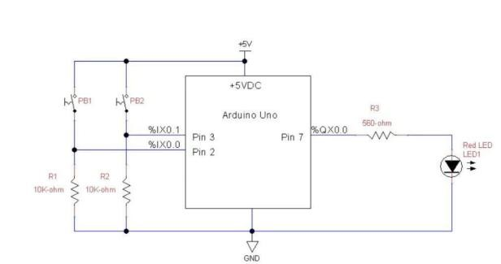
Step 2: OpenPLC Editor SampleOpenPLC editor :
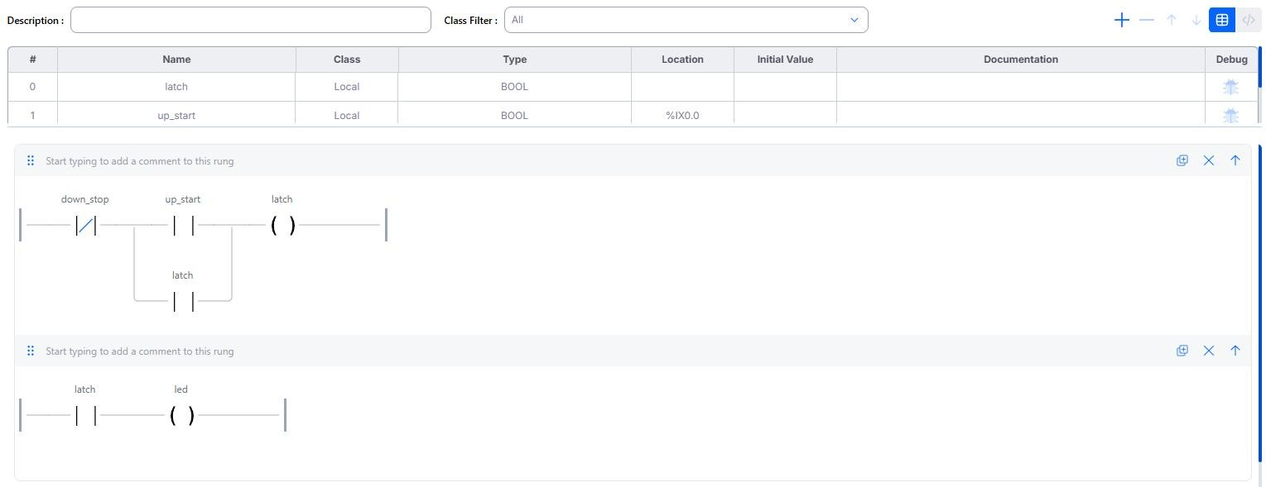

Data Collection
Task 1: Create and Simulate the Ladder Diagram using OpenPLC Editor for start-stop control circuit.
Test  No | CONDITION | INPUT | OUTPUT
1 | START BUTTON  PRESS | ON | LED ON
2 | STOP BUTTON  PRESSED | OFF | LED OFF
3 | BLINKING LED  SIMULATION | TIMER ACTIVE | LED BLINKING
4 | LADDER LOGI | ARDUINO CONNECT | TWO WAY SWITCH FUNTION

Data Analysis
Task 1: Create and Simulate the Ladder Diagram using OpenPLC Editor for start-stop control circuit.
The configuration data extracted from the project documentation defines the physical mapping and programmatic execution rules required to establish an automated start-stop sequence:
Input Data Mapping: Two physical hardware pushbuttons are monitored via Boolean registers. The UP_Start button is assigned to location address %IX0.0 (physical Pin 2 on the microcontroller), and the DOWN_Stop button is mapped to location address %IX0.1 (physical Pin 3). Output Data Mapping: The status indicator (LED) is designated as a digital output variable, assigned to memory address %QX0.0 (physical Pin 7). Internal Status Flags: An internal software-defined Boolean variable (Latch) is configured with local programmatic scope to maintain state memory independently of physical contact state changes.

Significance of the Data
The data collected and organized in the variable configuration table is foundational for the transition between standard consumer software applications and deterministic industrial operational technology (OT):
IEC 61131-3 Standardization: The variable parameters (Name, Class, Type, Location) explicitly satisfy the structural regulations of the IEC 61131-3 global standard for programmable controllers, ensuring standard-compliant behavior across platforms. Hardware Interfacing Bridge: The specific syntax within the "Location" column (using %IX for inputs and %QX for outputs) translates arbitrary micro-controller registers directly into concrete PLC memory partitions. Without this strict data alignment, compiling runtime logic into targeted physical control patterns would fail.

Results
Task 1: Create and Simulate the Ladder Diagram using OpenPLC Editor for start-stop control circuit.
The programming execution produced a working control system split across two distinct rungs within the OpenPLC programming environment:
RUNG | Logic path component | result
1 | Negated Contact (DOWN_Stop)  Parallel Network [Normally Open Contact  (UP_Start)  Normally Open Contact (Latch)] Output  Coil (Latch) | Pressing UP_Start completes the circuit loop and energizes the Latch coil. Once energized, the parallel Latch contact maintains current flow even after releasing UP_Start
2 | Normally Open Contact (Latch)  Output Coil (LED) | Continuous activation of the internal Latch register forces the immediate, stable energization of the LED hardware output.

Discussion
The programmatic behavior of the OpenPLC configuration aligns directly with classical motorcontrol sealing circuits traditionally deployed across major assembly operations. The logic implements a Stop-Dominant Latch Circuit.
By nesting the parallel execution block downstream of the negated DOWN_Stop contact, safety constraints are effectively integrated into the software. When an operator triggers a stop condition, the negated contact breaks connection continuity immediately, starving downstream nodes of logic power and breaking the latch state.

Interpretation of Results
The operational state changes confirm standard latching performance:
- Quiescent State: Both inputs are unpressed. Because DOWN_Stop is a negated contact, it evaluates as True. However, because UP_Start and the feedback Latch contact are open (False), the Latch coil remains unenergized (False).
- Momentary Activation: Pressing UP_Start satisfies the rung continuity conditions. The Latch coil switches to True, which instantly forces the parallel Latch contact on Rung 1 and the series Latch contact on Rung 2 to transition to True.
- Sustained Execution: Releasing the UP_Start button opens its specific contact. However, current continues to pass through the closed parallel Latch contact, successfully maintaining a closed circuit loop to keep the LED powered.

Implications of the Results
Proving that software logic can execute deterministic, safe latching mechanisms over microcontrollers opens up major cost-reduction opportunities. It demonstrates that open-source ecosystems like OpenPLC can replace expensive, proprietary industrial controller platforms for low-to-medium risk automated deployments. Engineers can test structural control sequences using budget-friendly micro-controllers before deploying the final compiled logic files directly onto robust, ruggedized industrial PLC networks.

Discrepancies Between Expected and Observed Outcomes
During baseline operations, no structural logical variations were recorded between the OpenPLC interactive software simulation model and the physical deployment on the Arduino board.
- Expected behavior: Pressing the start switch lights up the LED; pressing the stop switch turns it off safely.
- Observed behavior: The physical hardware responded correctly to the digital commands.
Any differences encountered in practical lab scenarios are generally limited to small differences in response timing. The desktop simulation updates instantly based on CPU cycles, whereas physical hardware introduces subtle microsecond propagation delays through the physical input and output lines.

Sources of Error and Limitations
Mechanical Switch Bouncing: Hardware pushbuttons rely on flexible metal elements that mechanically vibrate upon contact. This behavior can cause the controller to read multiple fast high-and-low voltage cycles, potentially leading to instability in fast-scanning PLC rungs. No Voltage-Drop Protection: The ladder logic assumes input signals are clean and clear. In settings with high electromagnetic interference (EMI), long input wires can pick up electrical noise, which the micro-controller might misinterpret as false activation triggers. Volatile Memory Dependencies: Because the internal state memory is managed entirely in local RAM, a sudden power failure or hardware reset wipes out the current latch status, returning the system to its unstarted baseline state upon reboot.
·

Summary of Discussion
The investigation successfully combined software logic design with physical hardware interfacing using the OpenPLC environment. By systematically mapping physical digital pins to normalized software variables, a standard stop-dominant control circuit was created, simulated, and deployed onto hardware. The systematic review shows that while open-source software solutions match the logical accuracy of commercial PLC systems, real-world hardware factors like contact bouncing and electrical protection require careful design consideration.

Conclusion
The experiment successfully achieved its core objectives. Using the OpenPLC platform to create an IEC 61131-3 compliant ladder logic program demonstrates that standard microcontrollers can run industrial control sequences reliably. The start-stop control circuit operated safely under simulation and responded correctly when deployed to hardware, proving that opensource automation tools are highly effective for educational and industrial prototyping applications

Recommendations
- Incorporate Standard Debounce Filters: Add a Software Off-Delay (TOF) or On-Delay (TON) timer block directly to the UP_Start and DOWN_Stop input channels to isolate and filter out transient contact bouncing noise.
- Deploy External Pull-Down Resistors: Use dedicated physical resistors (such as the 10 ohm components shown in the circuit diagram) on all digital input loops to ensure input lines tie cleanly to ground when switches are open, preventing floating pin states.

Improvements for Future Work
1. Integrate Modbus/TCP Networking Capabilities: Expand the system by enabling communication between the micro-controller and an external PC host via industrial Ethernet protocols, allowing real-time monitoring and remote system overrides.
 Add Non-Volatile Memory Latching: Upgrade the internal registers to write their state to non-volatile EEPROM memory. This ensures that if the system suffers a sudden power loss, it can safely resume its last operational state when power is restored.

Insights and Lessons Learned
● The Necessity of Hardware-Software Mapping Standardization:
A major insight gained was how open-source platforms bridge different environments. Simply writing logical code is useless without an exact addressing syntax (like using %IX for physical hardware inputs and %QX for outputs). Correctly binding these software registers to microcontroller pins is the most critical step in ensuring an automated system executes safely and predictably in the real world
- Teamwork and Problem Solving:
Implementing an integrated system required careful coordination and iterative testing. Collaboration and systematic troubleshooting proved crucial in achieving consistent and reliable results.
- Decoupling System Logic via Internal Flags:
Designing the start-stop sequence highlighted the value of using an internal memory bit (Latch) rather than wiring physical components directly to one another in series. Using software-based holding contacts isolates the core control states from sudden, unpredictable physical hardware changes, allowing developers to create highly sophisticated, multi-stage automation sequences with fewer physical components.
Overall Recommendation:
Future students are encouraged to build upon this experiment by exploring wireless data transmission (e.g., Bluetooth or Wi-Fi), machine learning for motion recognition, and cloudbased monitoring. These enhancements would transform the system from a prototype into a more advanced, real-world IoT access control application.

References
- OpenPLC Open-Source Initiative & Documentation Portal. Available: https://autonomylogic.com/
- PLC Ladder Logic on an Arduino: Introduction to OpenPLC," Control.com Technical
Repository. Available: https://control.com/technical-articles/plc-ladder-logic-on-an-arduinointroduction-to-openplc/
- PLC Ladder Logic on an Arduino: Building a Start-Stop Circuit," Control.com Technical Repository. Available: https://control.com/technical-articles/plc-ladder-logic-on-an-arduinobuilding-a-start-stopcircuit/
Appendices

Appedic A-(OpenPLC editor)

Appendic B - (hardware )


Acknowledgments
We would like to express my sincere gratitude to my lecturer and lab instructor for their continuous guidance, clear explanations, and assistance with experimental setups throughout this experiment. Their detailed instructions with the several needed files attached have helped us understand how PLC Ladder Logic works and also setup the circuit connection.Therefore from that we are able to learn how to implement multi-layered security, such as Two-Factor authentication.
I would also like to thank the teaching assistants for their patience and assistance during the lab session. Their help in identifying wiring mistakes and explaining how to correct the logic in the program was very valuable.
In addition, I truly appreciate my classmates and lab partners for their teamwork, cooperation, and ideas during the experiment. We worked together to troubleshoot connection issues, share components, and test the code to make sure everything functioned as expected.
Overall, the success of this experiment would not have been possible without the guidance and support from both the instructors and my lab partners.

Certificate of Originality and Authenticity
This is to certify that we are responsible for the work submitted in this report, that the original work is our own except as specific in references and acknowledgement, and that the original work contained herein have not been untaken or done by unspecified sources or a person.
We hereby certify that this report has not been done by only one individual and all of us have contributed to the report. The length of contribution to the reports by each individual is noted within this certificate.
We also hereby certify that we have read and understand the content of the total report and no further improvement on the reports is needed from any of the individual's contributors to the report.Therefore, we agreed unanimously that this report shall be submitted for marking and this final printed report has been verified by us.

Signature:
Understand /
Name: MOHAMED ZAWIR FARIS BIN MOHAMED FAUZI
Matric Number: 2329493 | Agree | /

Signature:  Name: MUHAMAD HARITH HAIKAL BIN ZULKIFLI  Matric Number: 2319963 | Read  Understand  Agree | /  /  /
Signature:  Name: MUHAMMAD AIDIL AIMAN BIN WAKIL @  MUHAMAD SYUKRI | Read  Understand  Agree | /  /  /
Matric Number: 2316967


